Soldering Stand
https://makerworld.com/it/models/996004#profileId-972323
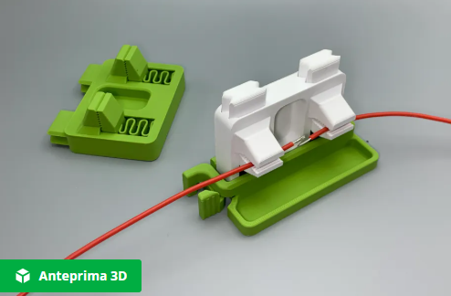

This is made from 2 parts:
→ Soldering base
→ Soldering clamp

This is the clamp (https://makerworld.com/it/models/873006#profileId-825284)

